Test Case : When Kelly string is provided under search bar
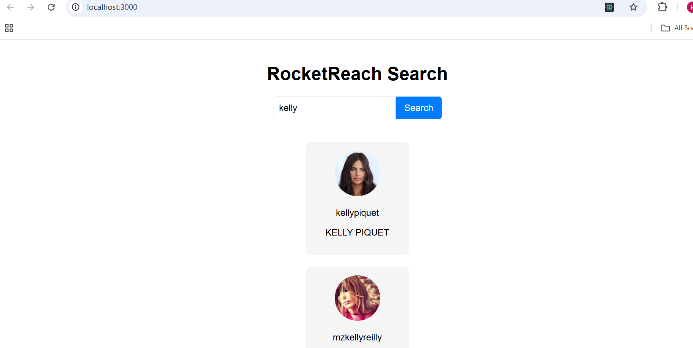

Test Case : When Ram string is provided under search bar

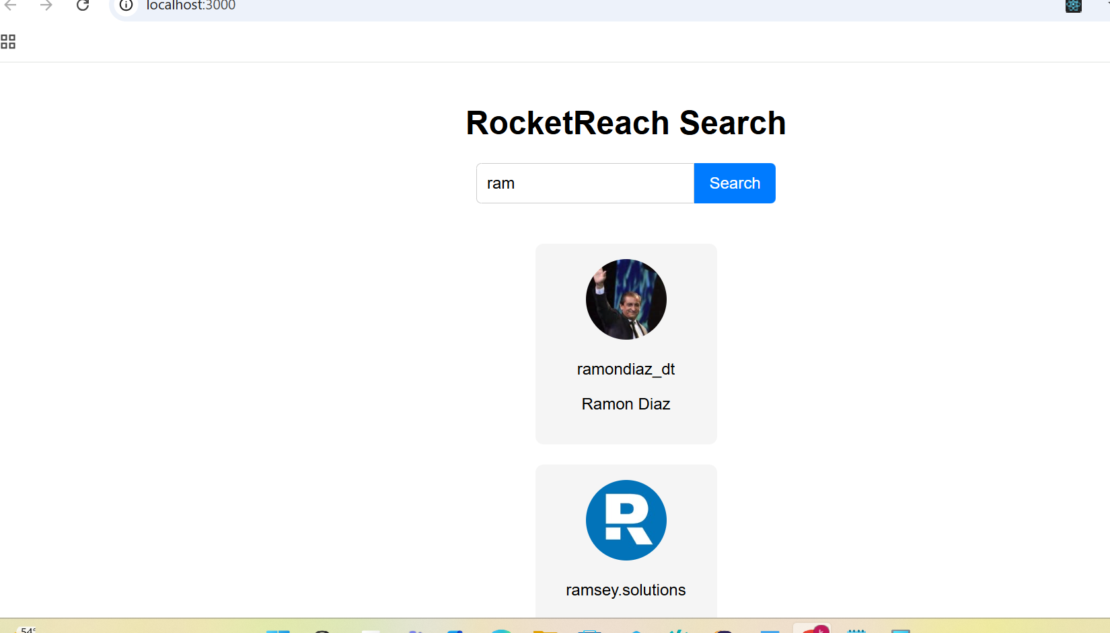
Test Case : When tried to paste the string

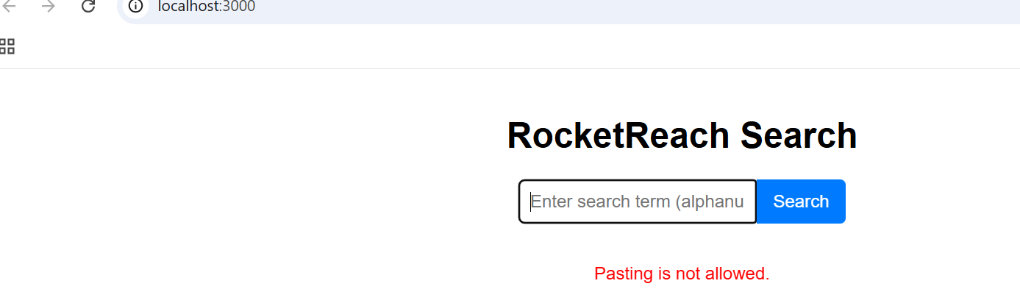
Test Case : When tried to enter more than 30 chars 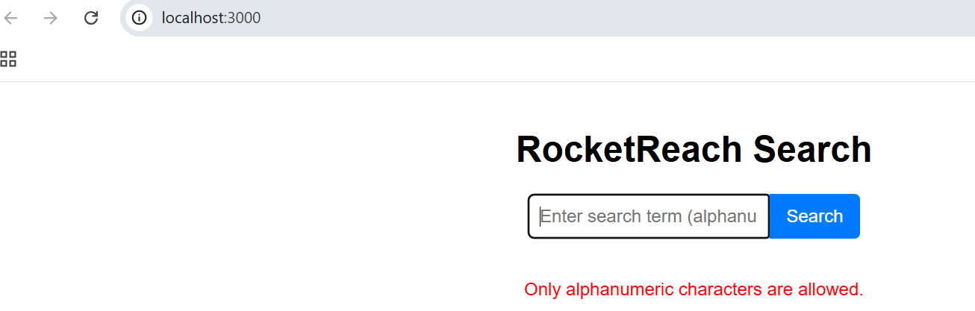
Test Case : When tried to enter special chars(other than alphanumeric)
